**ACCIDENT LOCATIONS ON INDIAN ROADS-**

**A report based on the study of Bangalore roads.**

Aaron Thomas Blessen, Abin Sabu Philip, Dr. Anju Pratap

Department Of Computer Science and Engineering

Saintgits College Of Engineering, Kerala

Abstract:- This project created a map of Bangalore showcasing the most accident-prone areas.

These locations were found by analyzing the Bangalore road accident data and mapped using a GIS tool Qgis. By analyzing the program output, we can also understand the speed, time, and months, at which most Accidents took place.

1. Introduction

India ranks first in the world for the number of accidents and lives lost on the roads. The country has only 1% of vehicles worldwide but has 11% of accidents worldwide. The Ministry of Road Transport (MoRTH) uses the concept of a Blackspot to mark these locations to improve road safety on national highways in the country. Moreover, States and local authorities also maintain a similar list of accident locations on road networks – typically with location names.

Road accident prediction is a significant area of research in traffic safety. Several factors influence the likelihood of road traffic accidents, including the geometric characteristics of the road, traffic flow patterns, weather conditions, time of occurrence, driver characteristics, and the overall road environment.

1. Problem Definition

The exponential growth of vehicles and accidents poses a pressing concern for road safety. It is imperative to take decisive measures to effectively address this issue in our country. Although various solutions exist, their proper implementation has been lacking thus far.

1. Proposed Solution

III-A. First Solution

Initially, the suggestion was made to utilize the datasets from the Ministry of Road Transports and Highways in Kerala. However, it was discovered that these datasets were limited, containing only 200 - 300 entries. As a result, the available dataset is significantly small, rendering it insufficient for the model to accurately analyze crucial factors such as accident-prone locations, speed, timing, and more.

III-B. Second Solution

The second solution involved utilizing a time series dataset of accidents in Bangalore, which provided more specific details and contained over 150,000 entries after undergoing data cleaning. Missing value imputation was performed using the K-nearest Neighbor Classifier, using another dataset that consisted of Bangalore ward data. This enriched dataset included specific details such as vehicle speed, accident timing, date of occurrence, and the type of accidents involved.

1. Methodology

The geographic area of Bangalore was specifically chosen for analysis in this project. The main objective is to identify the most accident-prone locations within Bangalore.

The dataset used for analysis was sourced from publicly available data, such as Kaggle and Bangalore Municipal data. Subsequently, data cleaning procedures were performed, including null value removal, data imputation, deletion of duplicate data, and other necessary steps. The project aims to go beyond identifying accident-prone locations by also analyzing factors such as the time of day, date, months, and speed at which accidents are most likely to occur in Bangalore. A machine-learning model, specifically the K Nearest Neighbour Classifier was developed using training data to address missing values.

To visualize and map the data, an application called QGIS (Quantum Geographic Information System) was utilized. The first step involved importing a map of Bangalore into QGIS. Following that, the data obtained from the data analysis program which contains information about the most accident-prone locations was imported into QGIS and the map was plotted on the map.

For precise location identification, the "show labels" feature was utilized to display the names of the locations on the map. Additionally, a graduated symbol technique was applied to categorize the accident locations into five equal parts and assign different colors based on the number of accidents occurring in each location. Finally, in the printout layout, it was possible to create a map in the preferred style.

This comprehensive approach combines machine learning, data analysis, and geospatial visualization techniques to gain insights into accident-prone areas, timing, and other relevant factors within Bangalore.

The map of the most accident-prone areas is given below.

1. Map

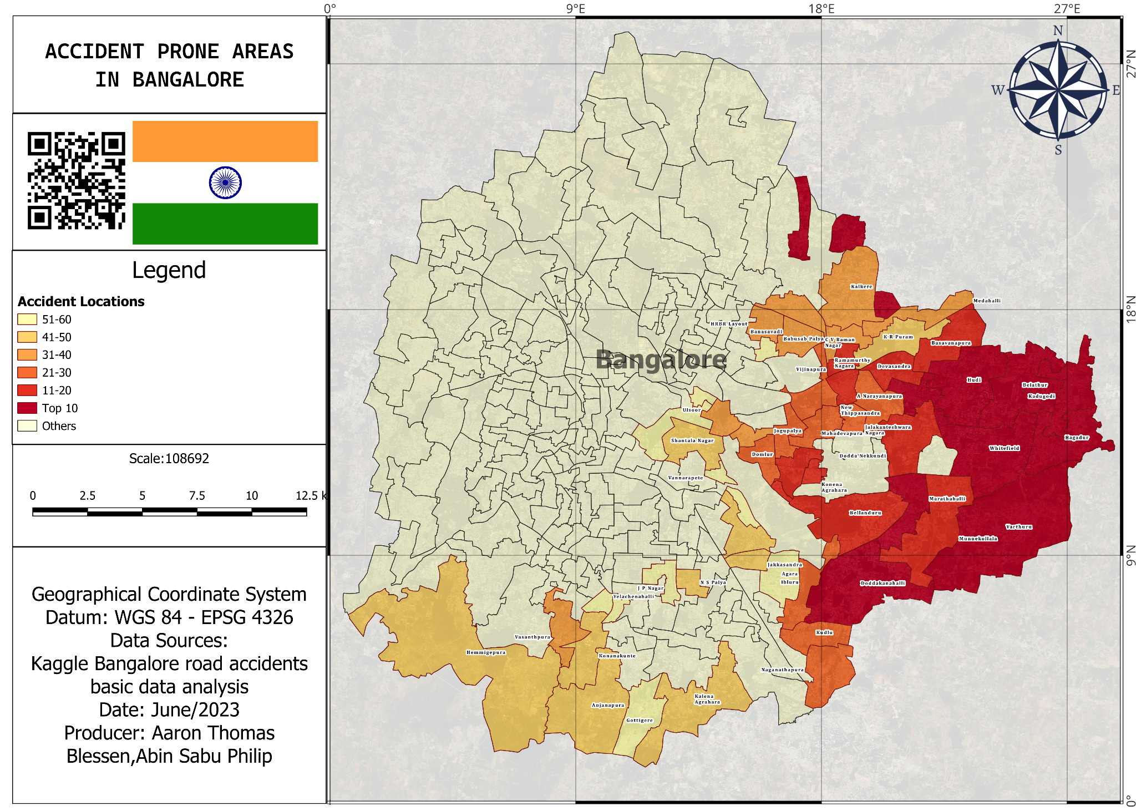

Figure (i)

1. Analysis and interpretation

Based on the data analysis model, it has been determined that Belathur, Hudi, and Whitefield are the most dangerous areas in Bangalore in terms of road accidents. The average speed at which most accidents occur is approximately 22 km/h. Additionally, the analysis revealed that the months of March and July have the highest number of accidents. Regarding the distribution of accidents throughout the week, there is a consistent trend except for Saturday and Sunday, with Sunday having the lowest number of accidents.

Furthermore, the hours of the day that exhibit noticeable variations in the number of accidents are from 6:00 am to 8:00 am and from 3:00 pm to 4:00 pm. These time periods are considered the most dangerous times to be on the roads in Bangalore. It's important to note that the above information is based on the data analysis conducted, and the provided details reflect the findings related to accident-prone areas, speed, months, days of the week, and specific hours in Bangalore.

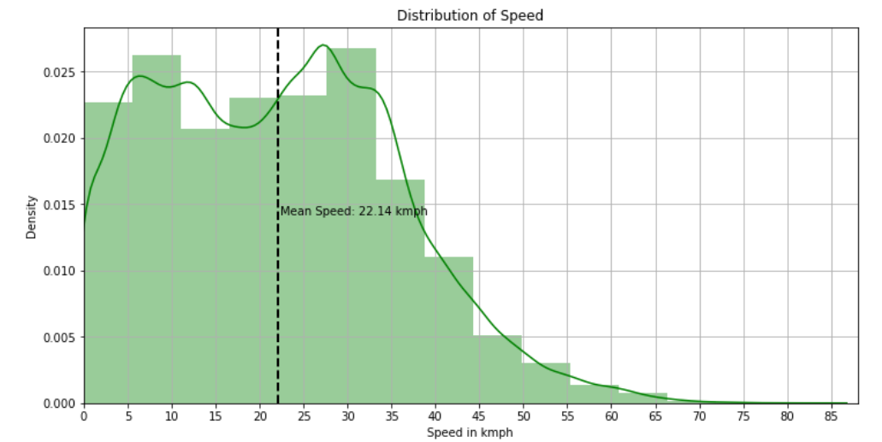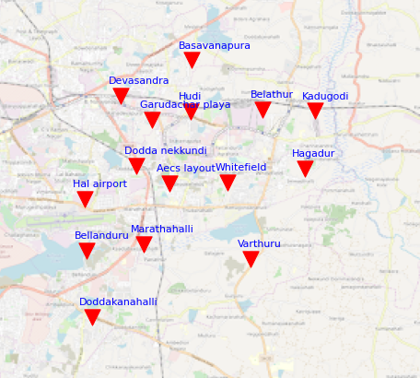

Figure(ii) Figure(iii)

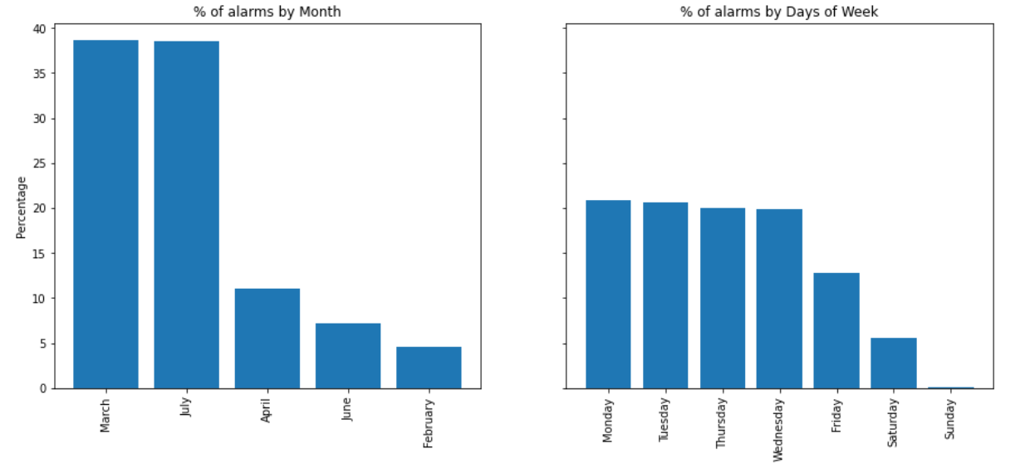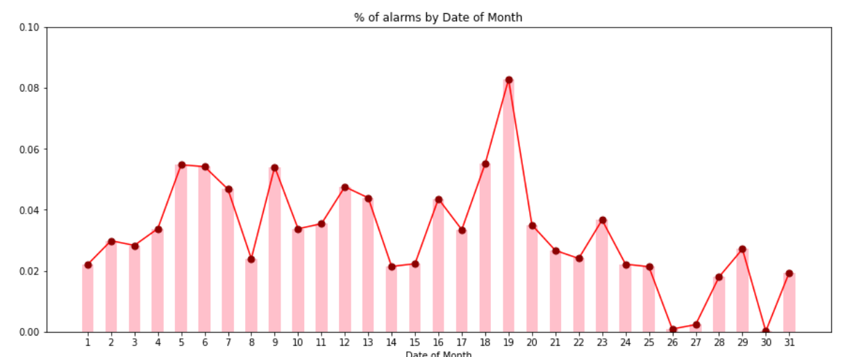

Figure(iv) Figure(v)

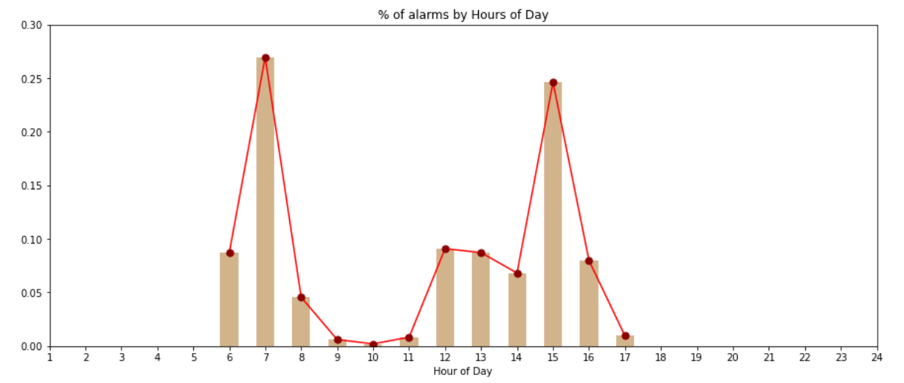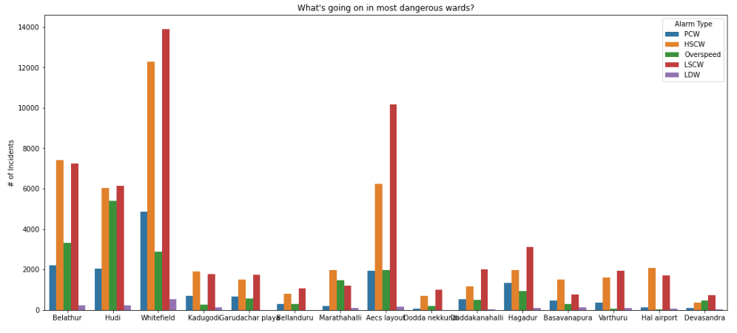

Figure(vi) Figure(vii)

1. Conclusions

This project successfully analyzed road accident data in Bangalore and created a map showcasing the most accident-prone areas in the city. By utilizing data analysis techniques and a GIS tool, valuable insights were gained regarding the locations, speed, timing, and months when accidents are most prevalent. The findings of this project highlight the urgent need to address road safety concerns in Bangalore and implement effective measures to reduce accidents and ensure the well-being of road users. The identification of specific accident-prone areas, such as Belathur, Hudi, and Whitefield, provides valuable information for targeted interventions and improvements in these locations.

Furthermore, understanding the factors that contribute to accidents, such as the average speed of around 22 km/h, the months of March and July witnessing higher accident rates, and the specific time periods of heightened risk during morning and evening commute hours, enables authorities to devise strategies to enhance road safety during these critical periods. Overall, this project demonstrates the importance of data analysis, machine learning, and geospatial visualization techniques in understanding and addressing road safety challenges. It sets the foundation for evidence-based interventions, improved traffic planning, and ultimately a safer environment for all road users in Bangalore.

1. Future

This project has the potential to extend beyond Bangalore and encompass other cities or regions in India. By analyzing road accident data and creating maps for multiple areas, the project can contribute to a comprehensive understanding of road safety challenges on a larger scale. To enhance its impact, the project can explore the integration of real-time data sources, such as traffic cameras, sensors, and social media feeds. This integration would enable live monitoring of road conditions and accident occurrences, providing valuable insights for immediate response and proactive accident prevention measures.

Moreover, building upon the existing machine learning model, the project can develop predictive analytics capabilities. By leveraging historical accident data and considering factors like weather conditions, traffic volume, and road infrastructure, the model can forecast accident-prone areas and times. This would enable authorities to take preemptive actions and implement targeted safety measures. To maximize the project's reach, integration with platforms like Google Maps could be considered. By alerting travelers about specific accident-prone locations, the project can enhance user awareness and contribute to safer journeys. Additionally, regularly sharing this information with the police department can aid them in enforcing road safety measures effectively.

By embracing these future directions, the project can continue making a significant impact on improving road safety, reducing accidents, and saving lives. It has the potential to become a valuable resource for decision-makers, researchers, and the community at large. By fostering a culture of safety and contributing to a sustainable transportation system in India, this project can drive positive change for road users nationwide.

1. References

<https://www.youtube.com/watch?v=9seReuWjZUg>

<https://www.kaggle.com/code/supratimhaldar/bangalore-road-accidents-basic-data-analysis>

<https://github.com/Aaron-Thomas-Blessen/intelunnati_TheElites>

<https://github.com/openbangalore/bangalore>

<https://github.com/Geeky-Sam01/Final_Year_Project>